# 

# World Class Mathematics for Parents:

# “What is it and what does it mean for my child?”

# 

Handouts

### Contents

* Handout 1: The Mathematical Practices (from the Standards) 2
* Handout 2: Airplane Turn-Round 4
* Handout 3: Key Capabilities 5
* Handout 4: Multiple Representations: Distance-Time Graphs 6
* Handout 5: Matching Graphs with Stories 7
* Handout 6: Linking Tables to Graphs and Stories 8
* Handout 7: Always, Sometimes or Never True? Distance–Time Graphs 9

Copying

*Except where noted/credited otherwise, these materials are Copyright © 2015-2017 Mathematics Assessment Resource Service, University of Nottingham. They are published under the* [*Creative Commons Attribution-NonCommercial-ShareAlike 4.0 International*](https://creativecommons.org/licenses/by-nc-sa/4.0/) *license, so they may be copied and adapted for non-commercial use under certain conditions and with appropriate attribution. Please see the license for details, or contact us via* [*http://mathnic.mathshell.org/contact.html*](http://mathnic.mathshell.org/contact.html) *if in doubt.*

*All MathNIC materials can be freely downloaded from our website* [*http://mathnic.mathshell.org/*](http://mathnic.mathshell.org/)

Handout 1: The Mathematical Practices (from the Standards)

The Standards for Mathematical Practice describe varieties of expertise that mathematics educators at all levels should seek to develop in their students. These practices rest on important “processes and proficiencies” with longstanding importance in mathematics education. The first of these are the NCTM process standards of problem solving, reasoning and proof, communication, representation, and connections. The second are the strands of mathematical proficiency specified in the National Research Council’s report *Adding It Up*: adaptive reasoning , strategic competence, conceptual understanding (comprehension of mathematical concepts, operations and relations), procedural fluency (skill in carrying out procedures flexibly, accurately, efficiently and appropriately) and productive disposition (habitual inclination to see mathematics as sensible, useful, and worthwhile, coupled with a belief in diligence and one’s own efficacy).

**1. Make sense of problems and persevere in solving them.**

Mathematically proficient students:

* explain to themselves the meaning of a problem and looking for entry points to its solution.
* analyze givens, constraints, relationships, and goals.
* make conjectures about the form and meaning of the solution attempt.
* consider analogous problems, and try special cases and simpler forms of the original problem.
* monitor and evaluate their progress and change course if necessary.
* transform algebraic expressions or change the viewing window on their graphing calculator to get information.
* explain correspondences between equations, verbal descriptions, tables, and graphs.
* draw diagrams of important features and relationships, graph data, and search for regularity or trends.
* use concrete objects or pictures to help conceptualize and solve a problem.
* check their answers to problems using a different method.
* ask themselves, “Does this make sense?”
* understand the approaches of others to solving complex problems.

**2. Reason abstractly and quantitatively.**

Mathematically proficient students:

* make sense of quantities and their relationships in problem situations.
  + *decontextualize* (abstract a given situation and represent it symbolically and manipulate the representing symbols as if they have a life of their own, without necessarily attending to their referents and
  + *contextualize* (pause as needed during the manipulation process in order to probe into the referents for the symbols involved).
* use quantitative reasoning that entails creating a coherent representation of quantities, not just how to compute them
* know and flexibly use different properties of operations and objects.

**3. Construct viable arguments and critique the reasoning of others.**

Mathematically proficient students:

* understand and use stated assumptions, definitions, and previously established results in constructing arguments.
* make conjectures and build a logical progression of statements to explore the truth of their conjectures.
* analyze situations by breaking them into cases
* recognize and use counterexamples.
* justify their conclusions, communicate them to others, and respond to the arguments of others.
* reason inductively about data, making plausible arguments that take into account the context
* compare the effectiveness of plausible arguments
* distinguish correct logic or reasoning from that which is flawed
  + elementary students construct arguments using objects, drawings, diagrams, and actions..
  + later students learn to determine domains to which an argument applies.
* listen or read the arguments of others, decide whether they make sense, and ask useful questions

**4. Model with mathematics.**

Mathematically proficient students:

* apply the mathematics they know to solve problems arising in everyday life, society, and the workplace.
  + In early grades, this might be as simple as writing an addition equation to describe a situation. In middle grades, a student might apply proportional reasoning to plan a school event or analyze a problem in the community.
  + By high school, a student might use geometry to solve a design problem or use a function to describe how one quantity of interest depends on another.
* simplify a complicated situation, realizing that these may need revision later.
* identify important quantities in a practical situation
* map their relationships using such tools as diagrams, two-way tables, graphs, flowcharts and formulas.
* analyze those relationships mathematically to draw conclusions.
* interpret their mathematical results in the context of the situation.
* reflect on whether the results make sense, possibly improving the model if it has not served its purpose.

**5. Use appropriate tools strategically.**

Mathematically proficient students

* consider available tools when solving a mathematical problem.
* are familiar with tools appropriate for their grade or course to make sound decisions about when each of these tools
* detect possible errors by using estimations and other mathematical knowledge.
* know that technology can enable them to visualize the results of varying assumptions, and explore consequences.
* identify relevant mathematical resources and use them to pose or solve problems.
* use technological tools to explore and deepen their understanding of concepts.

**6. Attend to precision.**

Mathematically proficient students:

* try to communicate precisely to others.
* use clear definitions in discussion with others and in their own reasoning.
* state the meaning of the symbols they choose, including using the equal sign consistently and appropriately.
* specify units of measure and label axes to clarify the correspondence with quantities in a problem.
* calculate accurately and efficiently, express numerical answers with a degree of precision appropriate for the context.
  + In the elementary grades, students give carefully formulated explanations to each other.
  + In high school, students have learned to examine claims and make explicit use of definitions.

**7. Look for and make use of structure.**

Mathematically proficient students:

* look closely to discern a pattern or structure.
  + Young students might notice that three and seven more is the same amount as seven and three more.
  + Later, students will see 7 x 8 equals the well-remembered 7 x 5 + 7 x 3, in preparation for the distributive property.
  + In the expression *x*2 + 9*x* + 14, older students can see the 14 as 2 x 7 and the 9 as 2 + 7.
* step back for an overview and can shift perspective.
* see complicated things, such as some algebraic expressions, as single objects or composed of several objects.

**8. Look for and express regularity in repeated reasoning.**

Mathematically proficient students:

* notice if calculations are repeated
* look both for general methods and for shortcuts.
* maintain oversight of the process, while attending to the details.
* continually evaluate the reasonableness of intermediate results.

Handout 2: Airplane Turn-Round



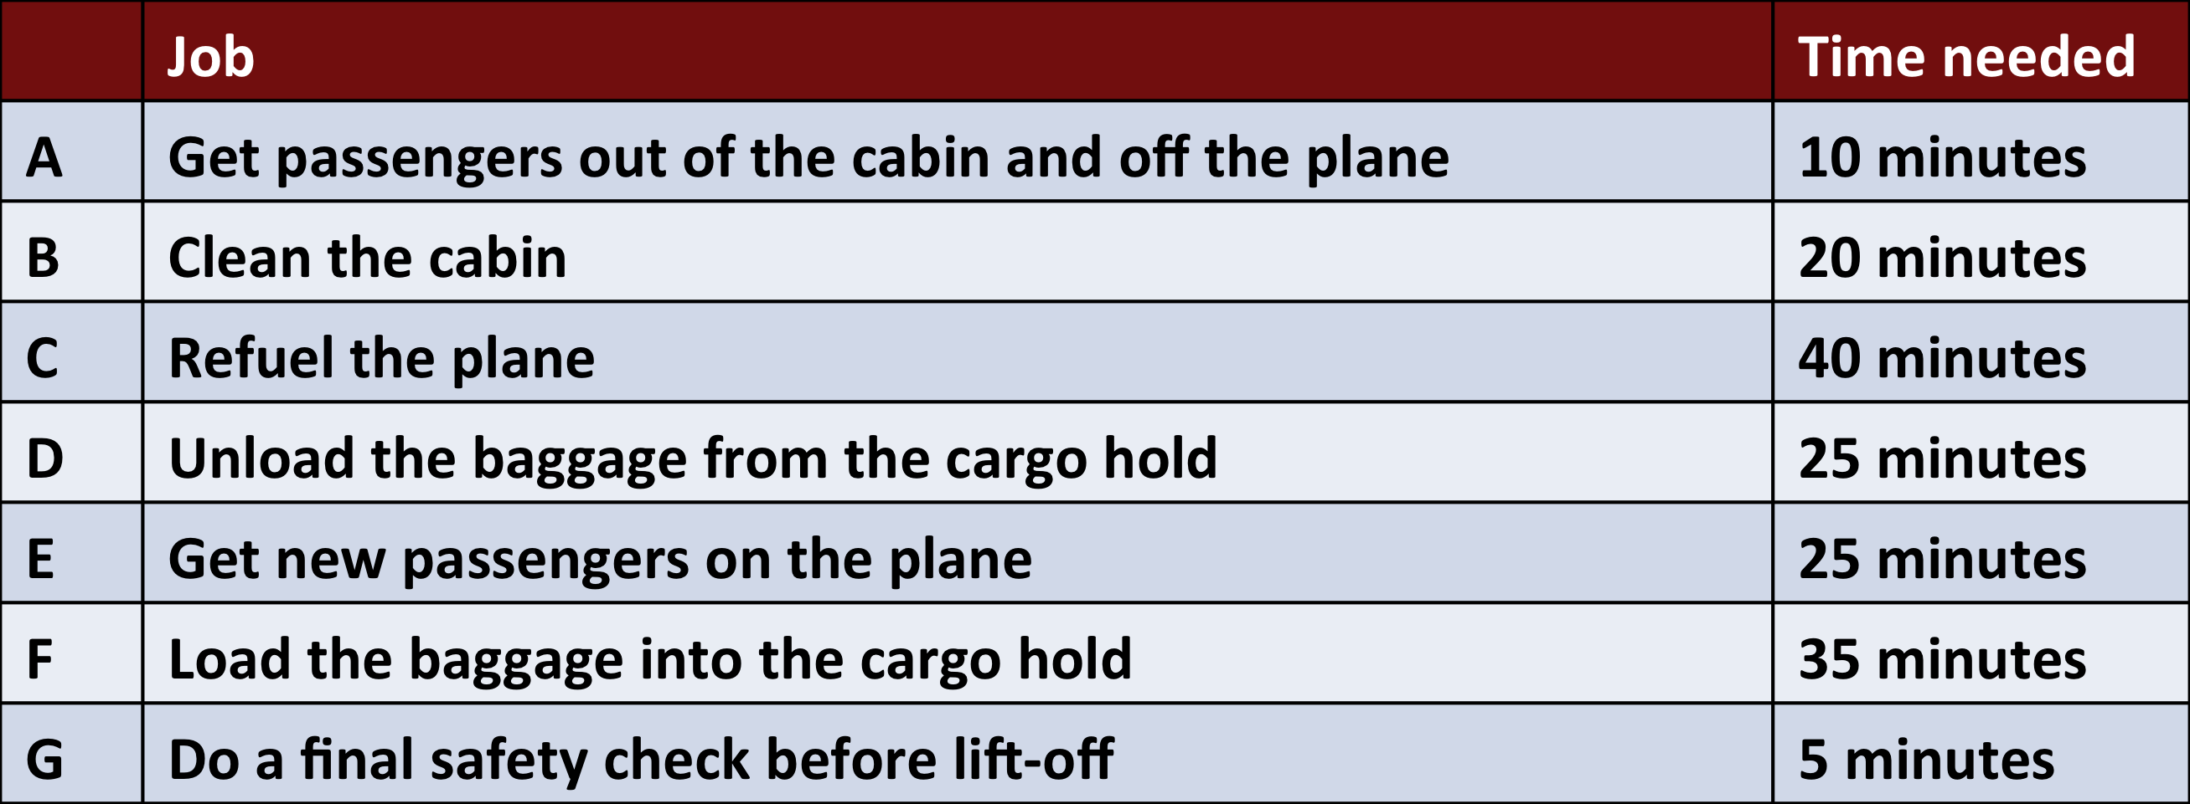

Between landing and taking off, the following jobs need to be done.

How much time is needed to get all of the jobs done?

Handout 3: Key Capabilities

What capabilities in general do you want your children to leave school with?

Make your list below.

Handout 4: Multiple Representations: Distance-Time Graphs

Every morning Tom walks along a straight road from his home to a bus stop, a distance of 160 meters.  
The graph shows his journey on one particular day.

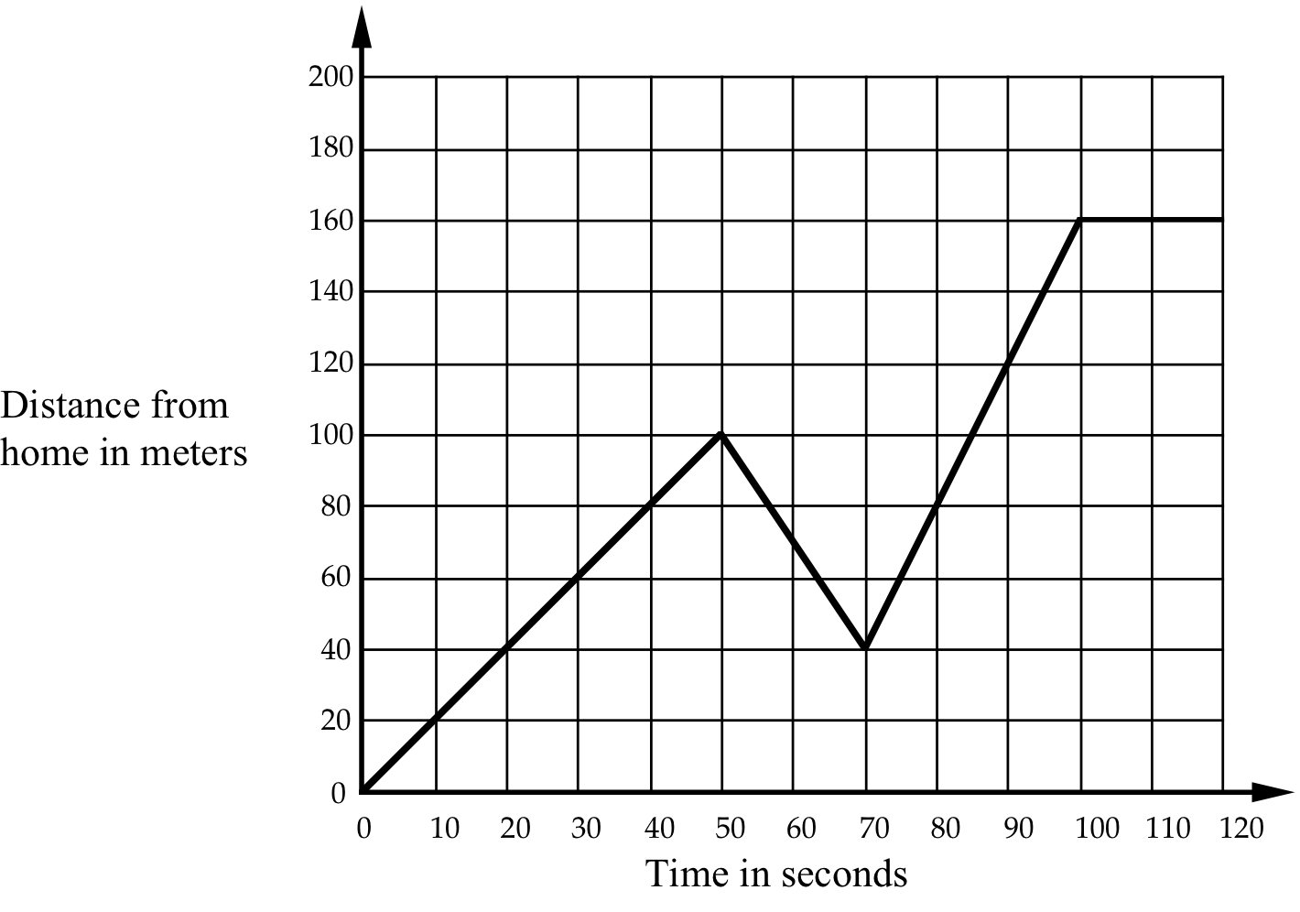

1. Describe what may have happened.  
You should include details like how fast he walked.

|  |
| --- |
|  |
|  |
|  |
|  |
|  |
|  |
|  |
|  |

2. Are all sections of the graph realistic? Fully explain your answer.

|  |
| --- |
|  |
|  |
|  |
|  |
|  |

Handout 5: Matching Graphs and Stories

Talk with your neighbors to work out how to match each of these graphs to one of the stories.



Handout 6: Linking Tables to Graphs and Stories

Talk with your neighbors to work out how to match each of these tables to a graph and a story.



Handout 7: Always, Sometimes or Never True?

* If you consider a statement to be always true, then try to explain how you know it is always true.
* If you think a statement is sometimes true, then try to describe all the cases when it is true and all the cases when it is false.
* If you think a statement is never true, then again explain how you can be sure.

|  |  |
| --- | --- |
| **Pay rise**  Max gets a pay rise of 30%.  Jim gets a pay rise of 25%.  So Max gets the bigger pay rise. | **Sale**  In a sale, every price was reduced by 25%. After the sale every price was increased by 25%. So prices went back to where they started. |
| **Area and Perimeter**  When you cut a piece off a shape you reduce its area and perimeter**.** | **Right Angles**  A pentagon has fewer right angles than a rectangle. |
| **Birthdays**  In a class of ten students, the probability of two students being born on the same day of the week is one. | **Lottery**  In a lottery, the six numbers  3, 12, 26, 37, 44, 45 are more likely to come up than the six numbers 1, 2, 3, 4, 5, 6. |
| **Bigger Fractions**  If you add the same number to the top and bottom of a fraction, the fraction gets bigger in value. | **Smaller Fractions**  If you divide the top and bottom of a fraction by the same number, the fraction gets smaller in value. |
| **Square Roots**  The square root of a number is less than or equal to the number | **Series**  If the limit of the sequence of terms in an infinite series is zero, then the sum of the series is zero. |