# Lesson Study for Professional Development

# 

# Handouts

### Contents

Handout 1: What are the characteristics of effective PD? 2

Handout 2: A problem solving task: “Outbreak!” 3

Handout 3: A Lesson plan for “Outbreak!” 4

Handout 4: The lesson as it happened 13

This is a draft version of this session – a revised version should be available Q2 2017.

### Copying

*Except where noted/credited otherwise, these materials are Copyright © 2015-2017 Mathematics Assessment Resource Service, University of Nottingham. They are published under the* [*Creative Commons Attribution-NonCommercial-ShareAlike 4.0 International*](https://creativecommons.org/licenses/by-nc-sa/4.0/) *license, so they may be copied and adapted for non-commercial use under certain conditions and with appropriate attribution. Please see the license for details, or contact us via* [*http://mathnic.mathshell.org/contact.html*](http://mathnic.mathshell.org/contact.html) *if in doubt.*

*All MathNIC materials can be freely downloaded from our website* [*http://mathnic.mathshell.org/*](http://mathnic.mathshell.org/)

Handout 1: What are the characteristics of effective PD?

What has been the most helpful and effective professional development you have undertaken?

|  |
| --- |
|  |

What made it so effective?

|  |
| --- |
|  |

List some of the characteristics of effective PD.

|  |
| --- |
|  |

Handout 2: A problem solving task: “Outbreak!”

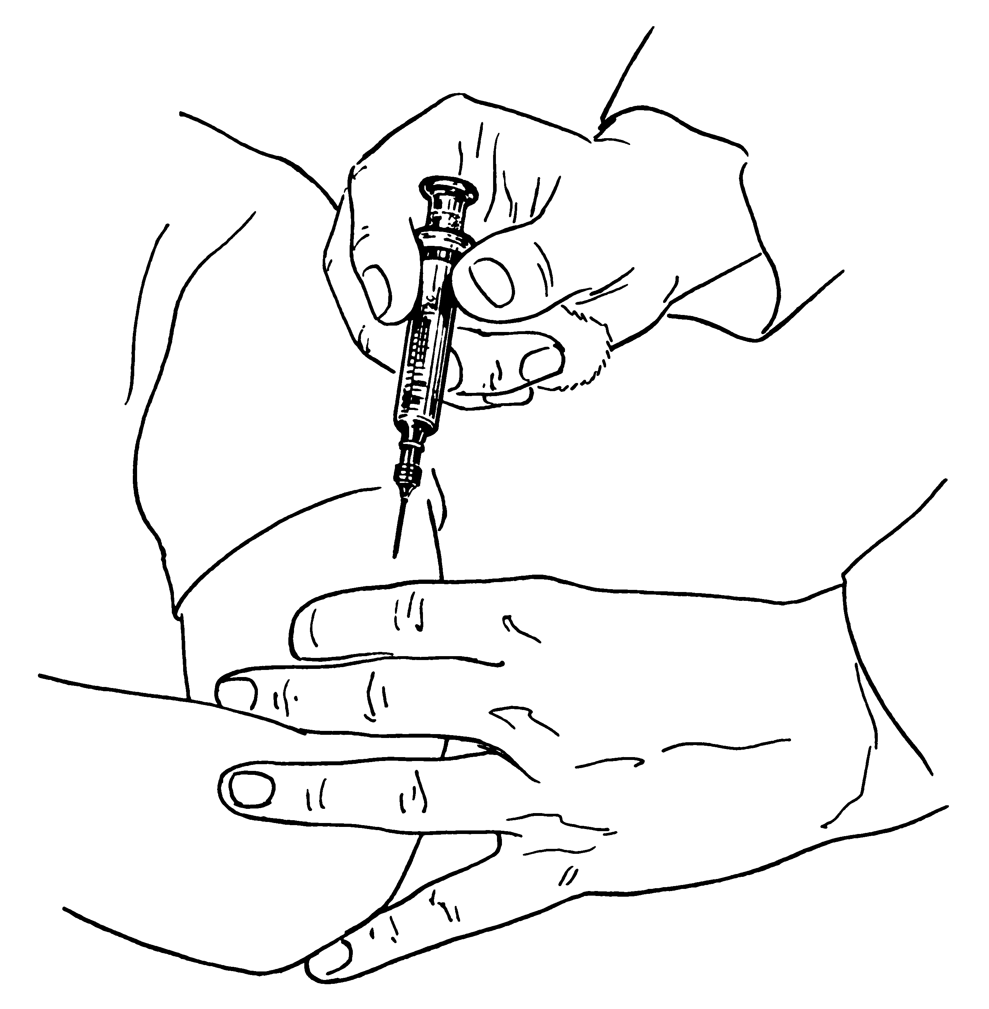The situation is getting extremely serious.   
A disease has started to spread around the city.  
If you get the disease you only have hours to live.   
Our city has been put under quarantine; no one in or out.   
The good news is you are able to help.

The scientists from the Research and Development Department have worked flat out and have managed to put together two vaccinations.

* Vaccination A is 100% effective and costs £12.00 per vaccine.
* Vaccination B is 70% effective and costs £5.20 per vaccine.

We only have a budget of £5,000,000 maximum.

Here is some information about the city population:

|  |  |
| --- | --- |
|  | Number in Population |
| Medical workers (doctors, nurses) | 75600 |
| Key service workers (electricity, refuse) | 113000 |
| Food shop personnel | 113000 |
| Farmers and food producers | 85100 |
| Other shop workers | 104000 |
| Other professionals ... teachers, lawyers, etc | 123000 |
| Other trades people … decorators, plumbers, mechanics etc | 85100 |
| Retired people | 86400 |
| Students and school pupils | 94600 |
| Children under 5 | 66200 |
| Total | 946000 |

Your task is to write a clear and concise report to the mayor recommending:

* How many of each vaccine should we make?
* Who will get those vaccines?

Remember, the mayor needs you to justify all of your decisions.

Handout 3: A Lesson plan for “Outbreak!”

### Target Class

This will only be the second lesson that the teacher has worked with the class of high attaining students. It is envisaged that the research lesson will be the second in a series of either three or four lessons. It is likely that this lesson and some of the next lesson will be focused around the strategic planning and writing reports to the “mayor” and presenting a sample of these to the class.

### Research Focus

The research question for this lesson is:

**How can we enable students to plan strategically and monitor their approaches more effectively?**

The research question, applied to the processes involved in the lesson:

* **Formulating the problem**:   
  Students need to select the data that is most relevant, then organize a strategic approach. For example, it is better to address the total vaccines available *before* deciding who receives them, rather than allocating them, then finding you have exceeded the budget.
* **Analyzing and solving**As they work on the problem, students need to monitor their approach and ask themselves monitoring questions such as: “Is this still within the budget?” “Will I have sufficient vaccine?”
* **Communicating, interpreting and evaluating**:   
  Students will communicate their own solutions and interpret and critique the planning of others.

### Introduction

The aim of this lesson is to encourage students to begin to plan the most effective strategy in order to solve the problem. At certain points throughout the lesson the teacher will attempt to encourage students to really think about solving the problem and ensure they do not get lost in the moment with what they are doing.

During the previous lesson the students will have been exposed to the context. Students will have been allowed approximately 15 minutes prior to this lesson to attempt to develop a first solution to the problem; this will inform plans to the content of the research lesson and important decisions, such as where the students will sit. The responses individuals make will also allow the teacher to ask specific question in written form, to address any misconceptions or further points that need clarifying.

### Resources needed

* The task “Outbreak!”
* Large sheets of paper, pens or pencils, calculators
* Individual mini-whiteboards, pens and erasers (optional)

### Time needed

Approximately 1 hour

### Anticipated issues with the task

These issues were informed by giving students 15 minutes to work on the task in a previous lesson.

|  |  |
| --- | --- |
| **Key issues** | **Suggested questions and prompts** |
| **Students start detailed calculations before planning an approach**  For example, they start at the top of the list and calculate the cost of vaccinating Medical workers, then move to next row etc. | * Describe in words a plan for tackling this problem. * What are the key decisions you have to make? * Which information are you going to focus on at the start, which will you ignore? |
| **Students ignore one or more constraints.**  For example, they forget that they only have £5 million budget, or that they only need 946000 vaccines. | * Do you have enough resources for your solution? * Have you made enough vaccine for everyone? * Have you wasted any money? * Have you wasted any vaccine? |
| **Students do not justify decisions made.**  For example, they state a solution with no explanation. | * Why have you chosen to allocate the vaccines in this way? * How can you be sure this is the best solution? |
| **Students that leap to conclusions**  For example, they quickly assume that only vaccine A should be used because it is most effective; or only vaccine B should be used because it is cheapest. | * Have you taken all the issues into account? * Could you vaccinate more people if you used some of vaccine B? * Could you save more lives if you used more of vaccine A? |
| **Students do not understand the concept of a budget**  For example, they assume a good solution will be a cheap solution and not realise they need to spend all of the budget to save most lives? | * What is your main objective when trying to solve the problem? * Are there any more lives that you could possibly save? |
| **Students being overwhelmed by the large numbers**  For example, if the spend £4.8 million of the budget, they might believe that is close enough to their maximum and not appreciate that with £200,000 you could save many more lives? | * How much money do you have remaining in your budget? * How many more vaccines would you be able to purchase with this amount of money? |
| **Students not grasping the meaning of their calculations**  For example, students might perform a sensible calculation but not understand what their answer represents? | * What does this figure represent? Is it how much money is left over or how much money has been spent? Does it represent an amount of people? |
| **Students only writing numbers with no justifications** | * Where have these figures come from? Do you know what they represent? Are you able to justify why you have used these numbers? |
| **Students not understanding the effectiveness of each vaccination**  For example, students might not be able to grasp the idea of something being 70% effective. | * If 1000 people were given vaccination B, how many would be likely to survive? |
| **Students becoming confused between numbers representing money or people**  For example, students might perform a calculation and get the solution 12500, but not know whether this is people or money. | * Can you think of a way of distinguishing between numbers that represent different values? * How can you distinguish between values that represent people or money? |

### Progression Grid

This grid shows what progress might look like on the two research areas.

|  |  |  |
| --- | --- | --- |
|  | **Strategic Planning** | **Monitoring work** |
| **Little progress** | * Attempts to work towards a solution by carrying out operations with figures but shows little strategic awareness that will lead to a solution | * Carries out own calculations without ever stopping to reflect or think about what is being achieved. * Does not stop to consider alternative approaches. |
| **Questions for progression** | * *Can you write down an action plan as to how you are going to complete the task effectively? What are the other pieces of information you need to consider?* | * *When you have finished this calculation, what will you do next?* * *What will your answer tell you?* * *How could you organise your work* |
| **Some progress** | * Carries out appropriate and correct calculations but does not take constraints into account. | * Briefly considers alternative approaches by comparing own method with others, but this has little or no impact on own approach. Continues to pursue an inefficient line of reasoning. |
| **Questions for progression** | * *Are there other pieces of information you have not thought about?* | * *Look carefully at your partner’s work / this piece of work that I have supplied.* * *What ideas does it contain that could help your own work?* |
| **Substantial progress** | * Works towards a solution logically reaching a viable solution | * Stops occasionally and considers the work of others carefully. Compares this with own approach and tries to make use of the approach. * Finds it difficult to discriminate efficient/ inefficient approaches to the problem, however. |
| **Questions for progression** | * *Can you think of an alternative approach to solving this problem? What be the effect on the outcome?* | * *Which of these two ideas is more powerful?* * *Why is this?* * *Which of these approaches could still work if we changed the numbers in the problem?* |
| **Task accomplished** | * Arrives at a solution having considered alternatives. | * Engages thoughtfully with the work of others. Selects and uses powerful approaches. |

Research Lesson Outline

### Seating plan changes

The teacher has assessed the initial attempts of the students and re-writes a seating plan to ensure that students with conflicting first attempts are sat next to each other.

### Re-introducing the lesson

The teacher displays the icon that was present on the worksheet from the previous lesson and asks the students to think about the problem they needed to solve last lesson:

*Talk to the person next to you about the problem from last lesson.   
What was it you were you trying to achieve?*

The teacher gives out copies of the task to the students.

Re-familiarise yourself with the task from last lesson.   
Today’s lesson is very much about planning a successful strategy. Think carefully about exactly what it is a successful strategy will look like, in other words what is it exactly you are trying to achieve?  
Discuss this with your partner. Once you are agreed, put this into writing at the top of your large sheet of paper.

### Looking at partner’s work

The teacher explains the purpose of this section of the lesson:

During the start of this lesson we will be considering different approaches to solving the problem you began last lesson. This will begin by you looking at your partner’s work. I would like you to complete the Green sheet (see below) using your partner’s work to fill it in.

Students are allowed adequate time to understand their partner’s work and then complete the sheet.

I want you to talk to your partner about their work. Take it in turns allowing them to explain what they did, why they did it and see if this is the same as what you were able to work out about their work. it was what you wrote down about them.

### Collaboration in pairs for a new approach

The teacher now distributes large pieces of paper and pens to allow for students to begin to make a new start on the problem.

*I want you to use the discussion you have just completed with your partner and also consider what you have already written down on your sheet of paper already to begin the planning part of the task together. By the end of this lesson you need to be close to a point where you are able to begin writing the report the mayor needs.*

During this period of time the teacher circulates the class, assessing what students are doing and providing feedback on their approaches where necessary. The teacher will also be looking for examples of students’ work that will be interesting to discuss during the neriage stage. If these are not forthcoming then some pre-prepared sample approaches will be provided for critique by the whole class. The samples that could be included in the lesson are to be found at the back of this lesson plan and are designed to be used as they are numerically correct, sound in their mathematical reasoning (although not necessarily unique or optimum) but not complete.

### Whole class discussion (Neriage)

The teacher will allow time for two conflicting approaches to be displayed. Students will have the opportunity to discuss in pairs what each approach is doing and then a whole class discussion will occur.

Students will be expected to discuss the approaches according to the following criteria:

* Is this looking like an effective and well-organized solution?
* Does the solution address all the constraints in the problem?
* Is it clear why the students have done what they have?
* What issues would arise if this solution was actually put into action?

Depending on how far along the students have got, these could be displayed on a PowerPoint.

### Re-drafting their approaches

After the whole class discussion students will have the opportunity to continue to work on their own approaches for a period of time.

### Summarizing and reflecting

During the summary the teacher will focus upon the strategic differences between solutions and draw out some general strategic points (from the class).

For example:

* It is better to address the total vaccines available before deciding who receives them, rather than allocating them, then finding that the budget is exceeded.
* A table is a powerful way of organising data, but may not be the only way.
* Keep checking that the constraints haven’t been exceeded.

Alternative approaches

It is important to realise that there are two phases to the problem; first look at whole population and work out the best number of vaccines, then decide how to allocate among the population.

If 946,000 are vaccinated with A, it would cost £11,352,000; or £6,352,000 over budget.   
If everyone is vaccinated with B, it would cost £4,919,200; or £80,800 under budget.   
(This would save approx. 0.7*946,000 = 662,200 people)

It is better to try to vaccinate as many as possible with vaccine A.

### Method A: Trial and adjustment.

***Using the constraint of people …***  
Suppose we only use vaccine A.   
It would cost 946,000 x 12 = £11,352,000 or £6,352,000 over budget.  
Now let us try to exchange some vaccine As for vaccine Bs.   
Each time we do this, it saves us £12 - £5.20 = £6.80  
£6,352,000 ÷ £6.80 = 934,117.   
So we need to change this number to Bs.

Assume we start by vaccinating everyone with vaccine B.   
It would cost £4,919,200; or £80,800 under budget. (1)  
Now let us try to exchange some of the vaccine Bs with vaccine As.   
Each time we do this, it costs us £12-£5.20 = £6.80  
Now 80,800/6.8 = 11, 882  
So we could vaccinate 11, 882 people with A and the rest (934,117) with B.

This would save approximately 11,882 + 0.7 * 934,117 = 665,765 people.

***Or, using the constraint of money…***

Suppose we only use vaccine B. We have enough money for £5,000,000 ÷ £5.20 = 961,538 vaccinations.   
But our population is only 946, 000 people.   
This means we would not need 15, 538 vaccines, saving us 15,538 x 5.20 = £80,800.  
We could now use this to buy vaccine As.   
(Rest is same as above (from 1)).

### Method B: Prioritising and updating

We begin by assuming we are going to only use vaccine A and therefore make the decision of who we want to save. Then we rank the groups of society into categories who we deem to be the most “useful”.

1. Medical Workers
2. Farmers and food producers
3. Trades people

Etc.

We then, use this as a basis for who receives which vaccination.

Medical workers (75600 x £12.00 = £907,200) which leaves 5,000,000 – 907,200 = 4,092,800

Farmers and food producers (85100 x £12.00 = £1021200) which leaves 4092800 – 1021200 = 3071600

And, then continue this process until there is no budget is left.

This process will require constant re-assessment to ensure what is left of society would be a harmonious one.

### Method C: Simplifying the problem

Students can be more “cut-throat” than adults and will therefore comfortably decide which sections of the populations are less useful than others. This ruthless approach, might actually be a good starting point for reducing the complexity of the constraints.

Method D: Algebra

Suppose we use *x* vaccines of A and *y* vaccines of B.

*x + y* = 946,000 (1)  
12*x* + 5.2*y* = 5,000,000. (2)  
  


Estimate of number saved = 11882 + (0.7*934,117) = 665,765 people

Although, this is a very elegant solution it still leaves student with the problem of allocating the vaccines.

Lesson Handouts: The Green Sheet

|  |
| --- |
| **Describe briefly what your partner has done** |
|  |
| **Why do you think they have done this?** |
|  |
| **How is this different from your approach?** |
|  |
| **What impact will this have on your next attempt at the problem?** |
|  |

Sample approaches

### Sample approach 1

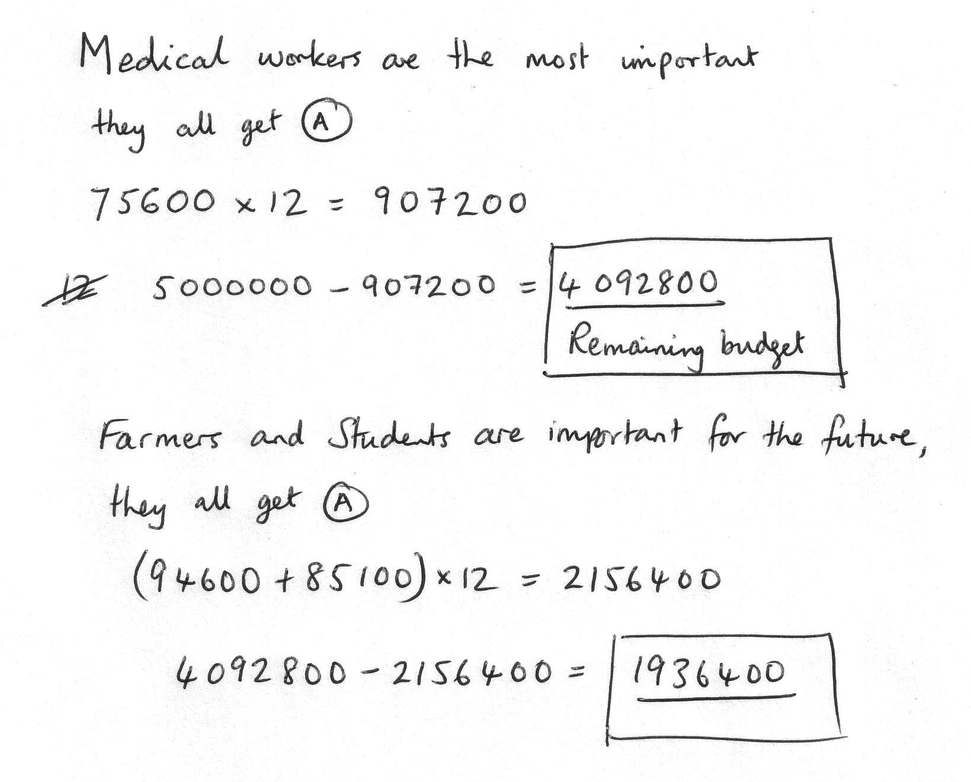

### Sample approach 2

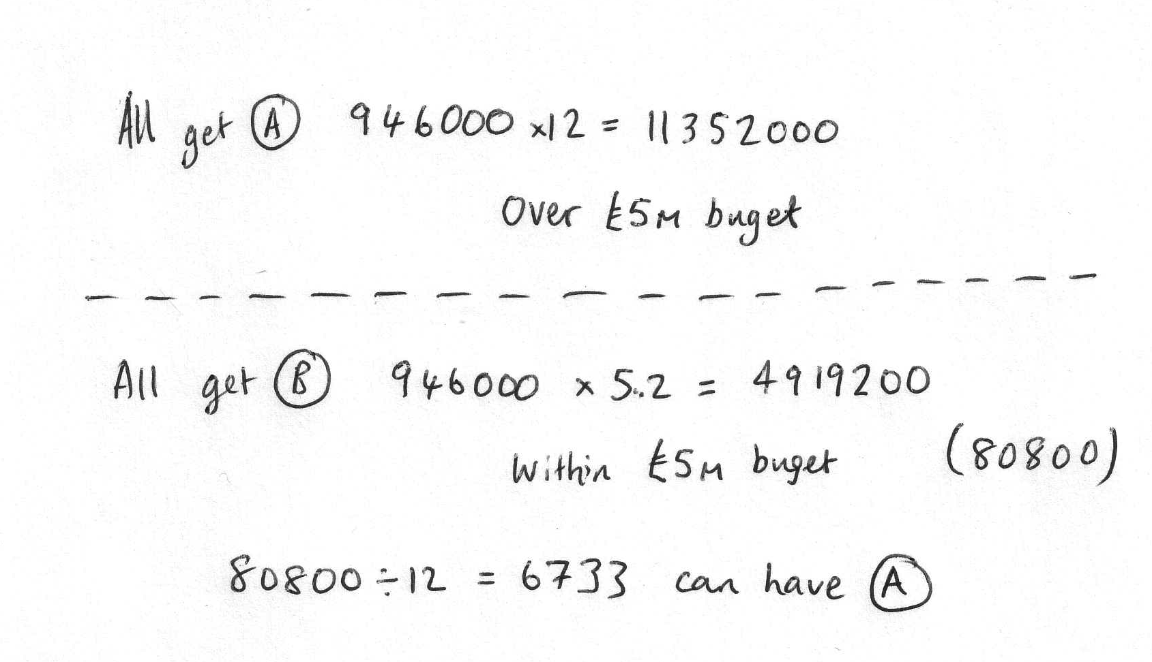

Handout 4: The lesson as it happened

|  |  |
| --- | --- |
| Phases of the lesson | How does it help with strategic planning or monitoring? |
| **Recall the task with partner.**  “Spend 30 seconds talking to the person sat next to you about anything you can remember about the task.” |  |
| **Review the task in silence**  “Spend a minute going over what it is all about, so that you are 100% familiar with the task.” |  |
| **Clarify the purpose of the task in pairs**  “The aim is about planning strategically how you are going to spend your budget. What are you trying to achieve? What is it that will make you successful?” Discuss with partner. |  |
| **Interpret and explain your partner’s approach**  “The person who is next to you has tried a different approach. Describe what they have done, why they have done this, how it is different to yours and what impact this will have on what you do next.” Silent writing on green sheet.  Tell your partner what they were doing. |  |
| **Produce a joint solution in pairs**  “By now you are probably thinking of a third method, considering what you’ve done, what your partner’s done and considering some mash up of those two ideas together.” |  |
| **Review the purpose of the task in pairs**  “Go back to what you are were trying to achieve at the beginning.” |  |
| **Two pairs present solutions**  What were their goals?  What was their approach? |  |
| **Plan for next time in pairs**  “How you will spend your next 15 minutes?” |  |